0. Lec: Fundamentals of Internet and Web Design
1. Lec: Introduction to Web Design

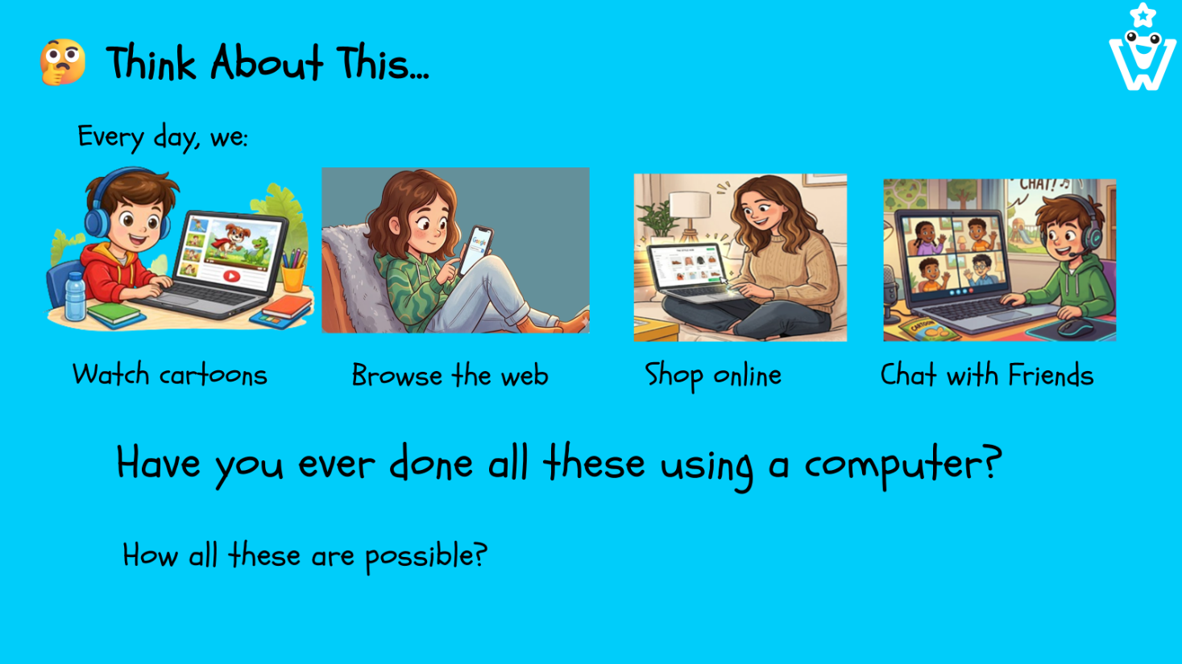

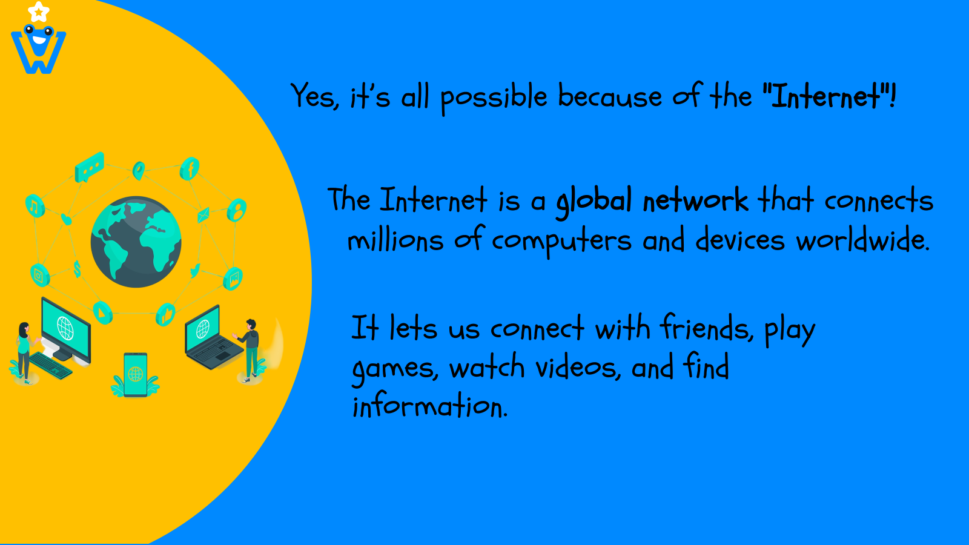
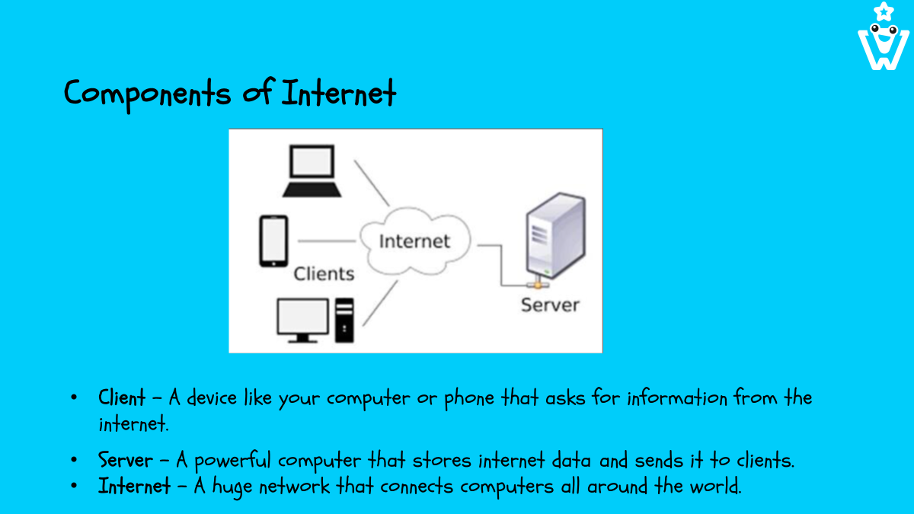

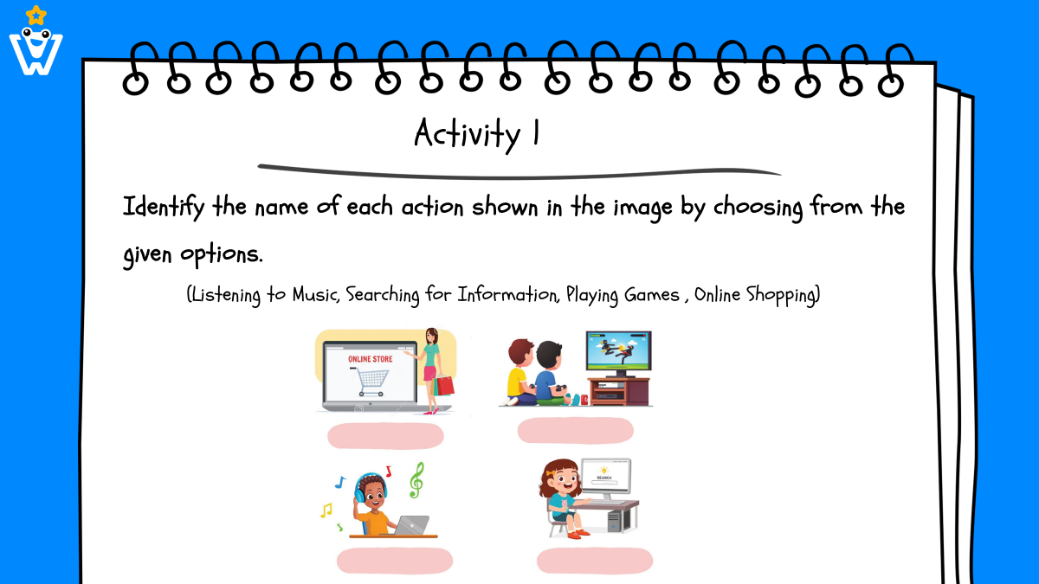

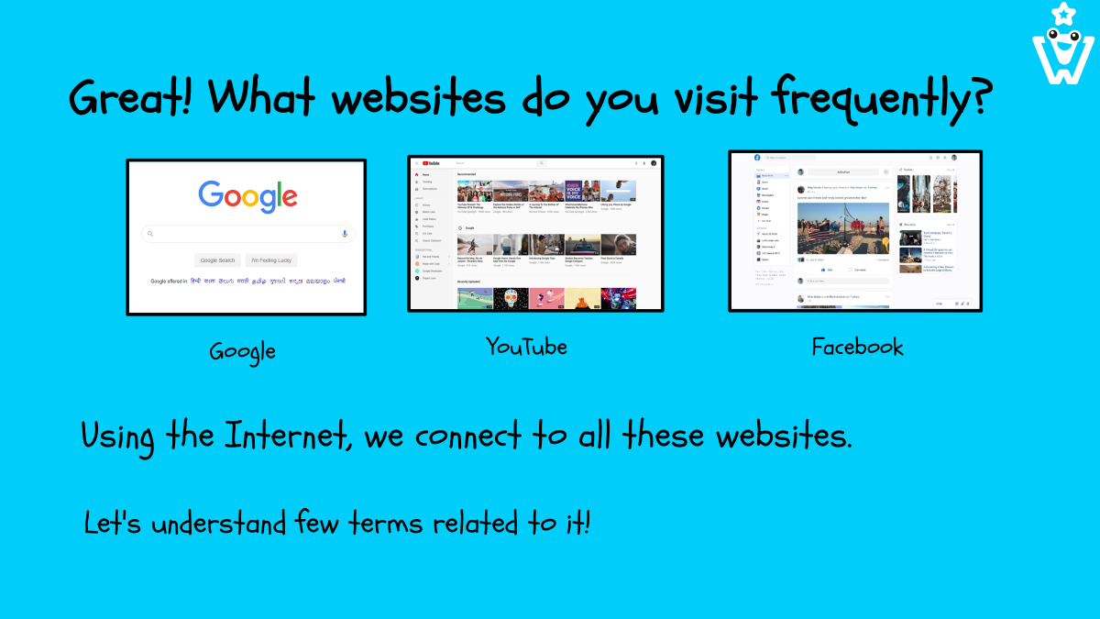

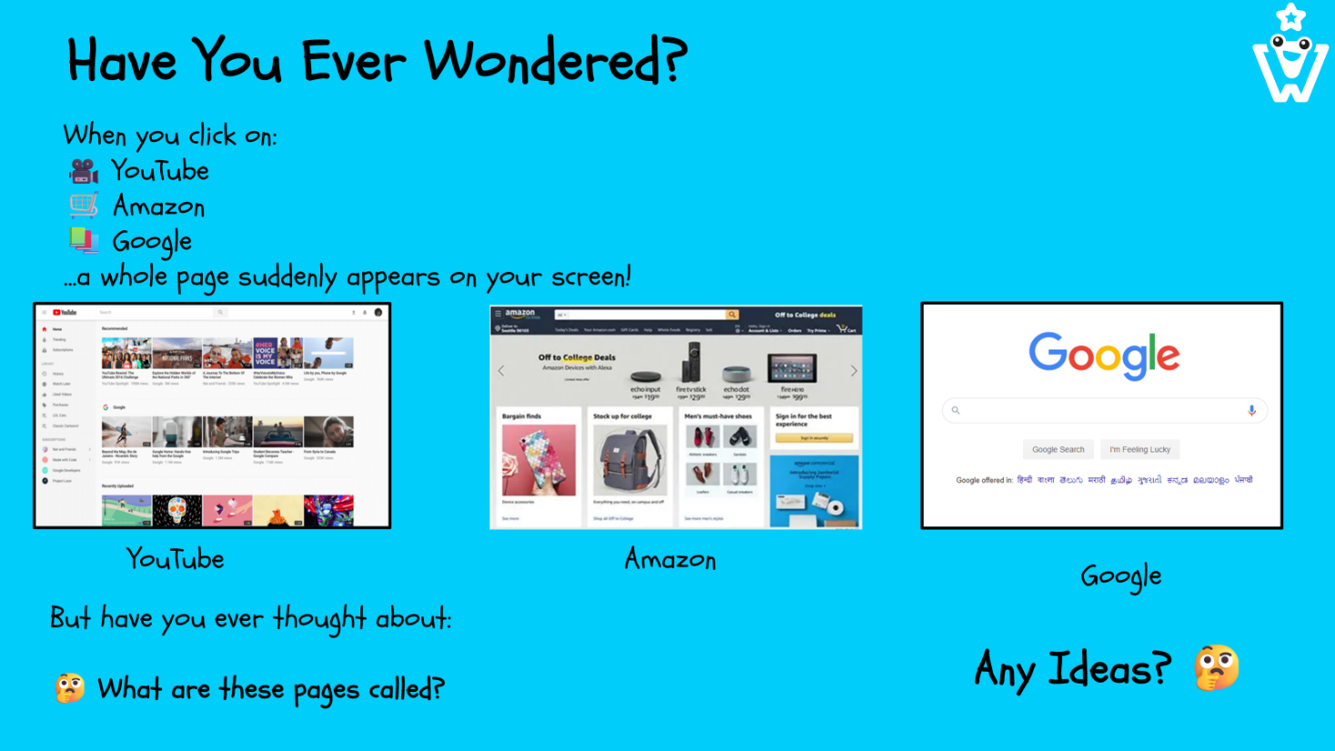
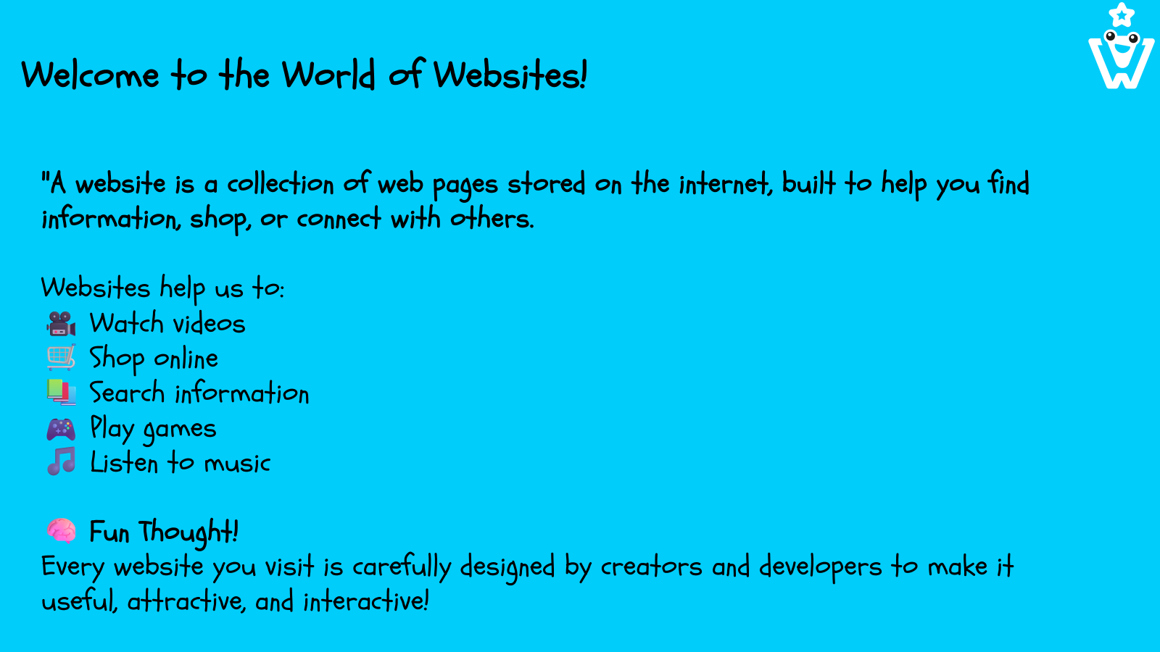
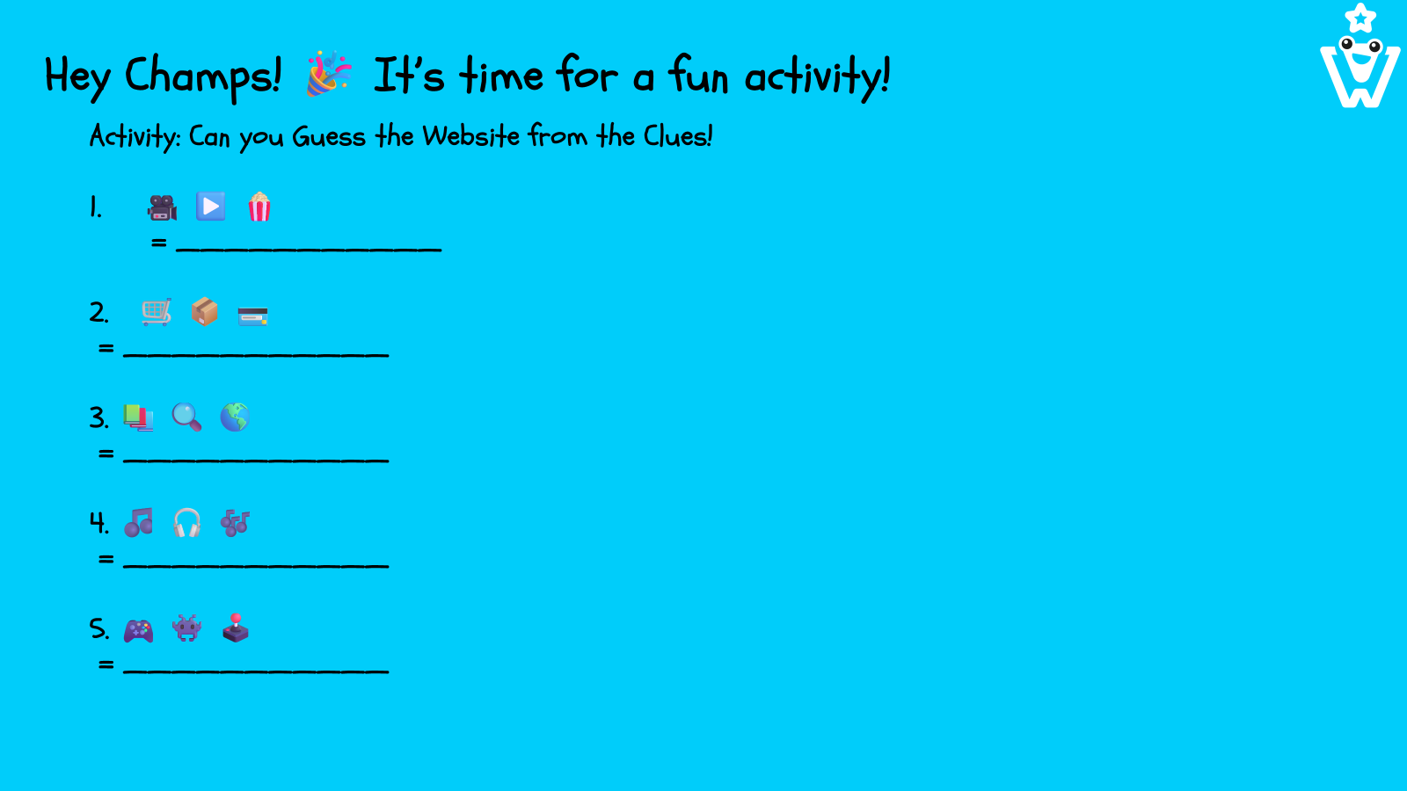

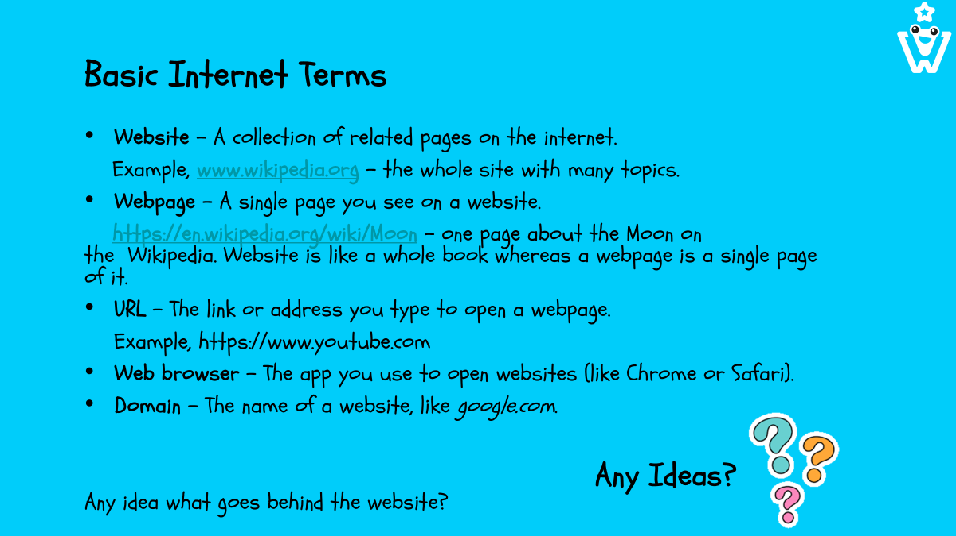

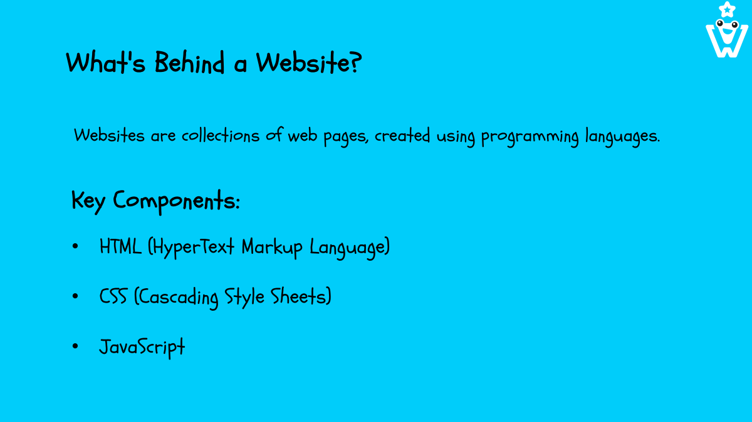
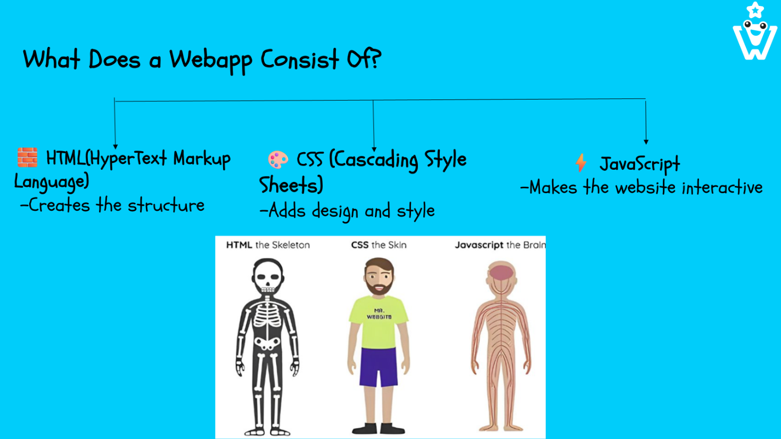
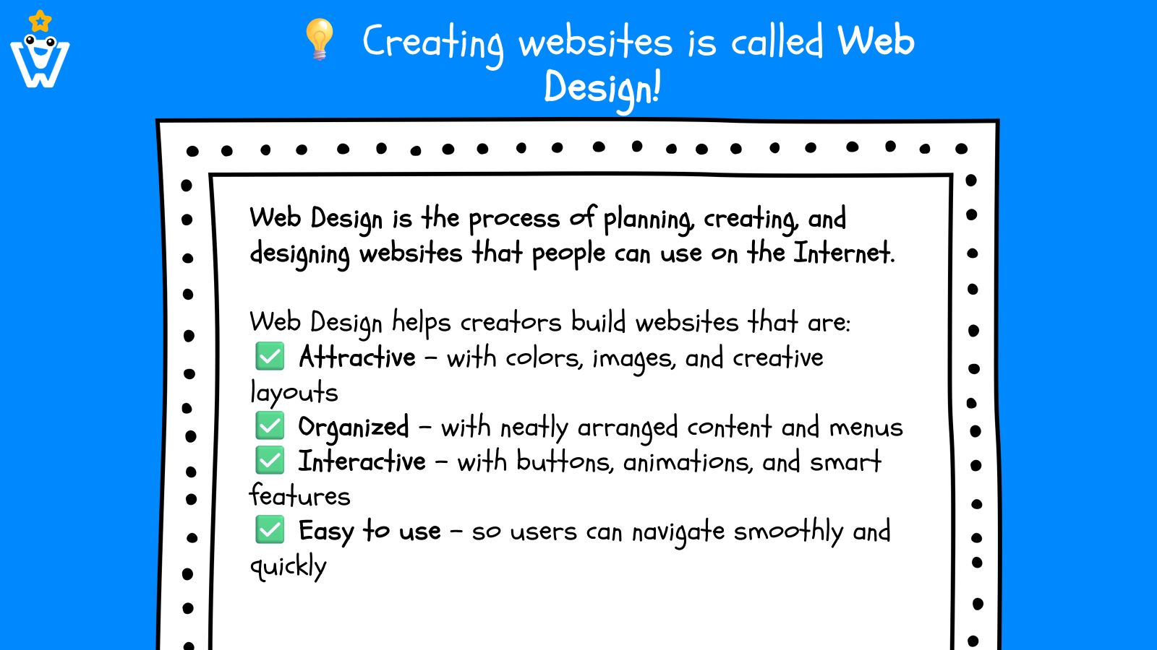
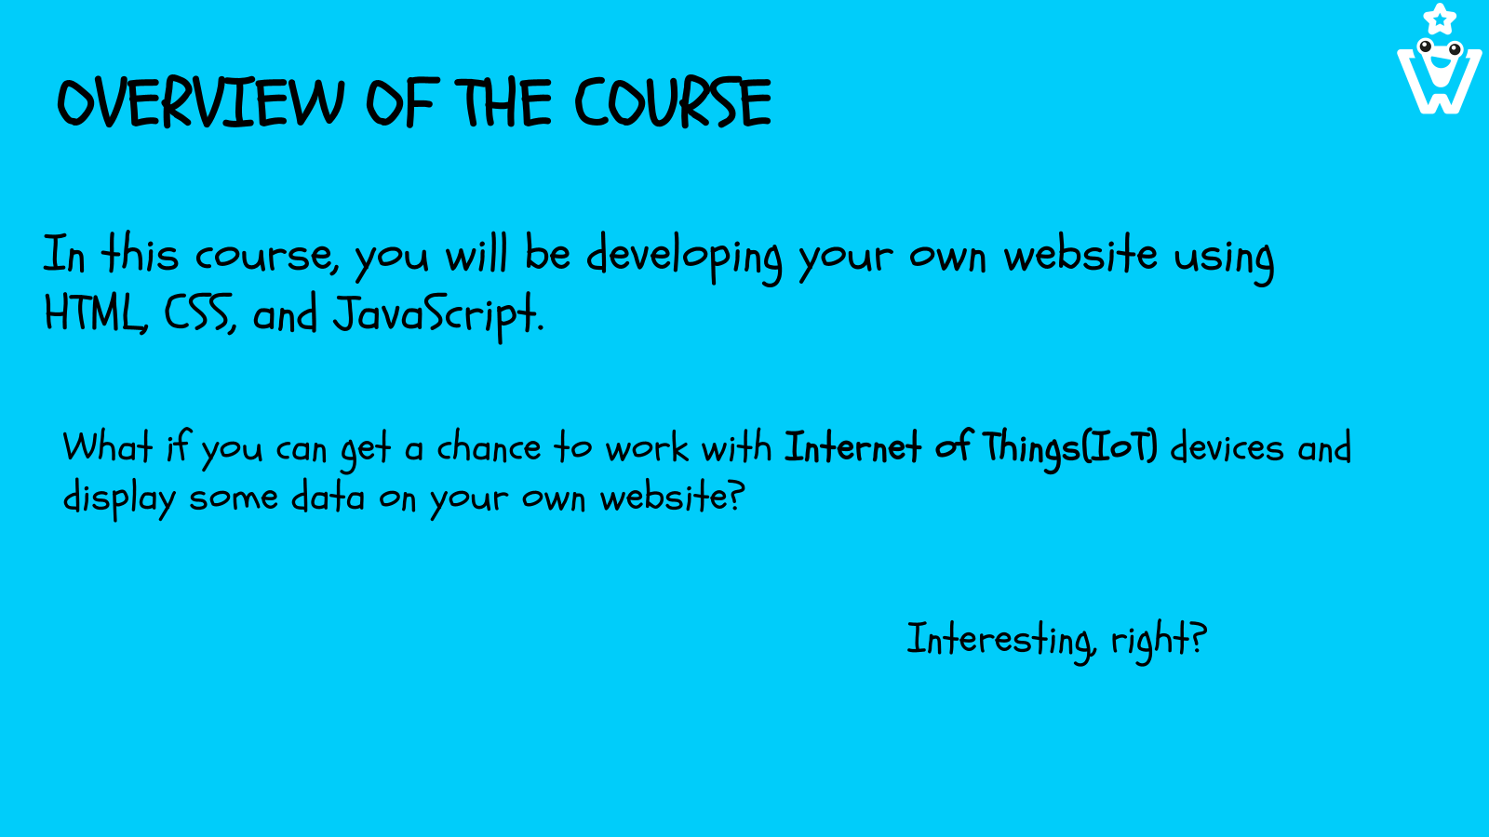
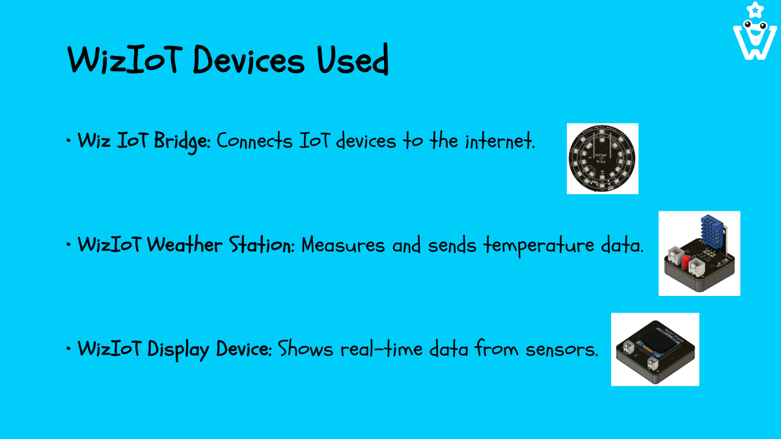
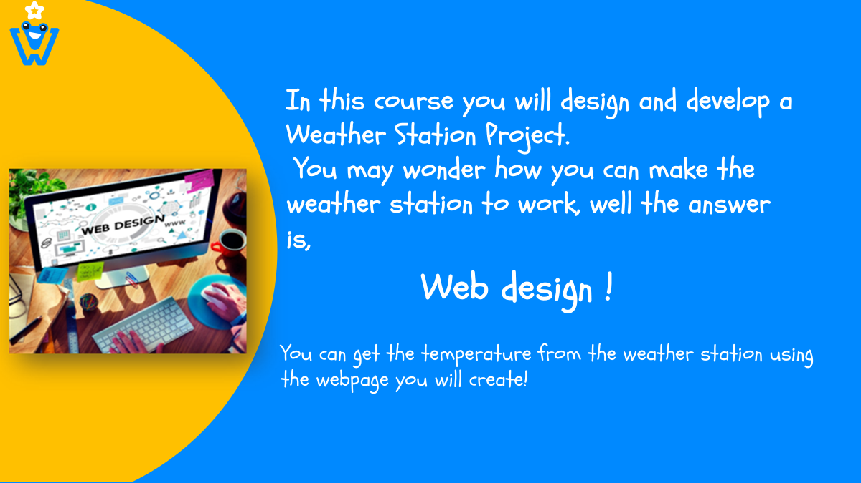

What is web design?
Think of web design like building a model city. Each website is a complete city (like New York or Paris), and each webpage is a building within that city.
Just as architects design buildings with doors and windows for easy navigation, web designers use elements like text, images, and menus to guide visitors. Colours, fonts, and images add unique decoration, ensuring the site is both attractive and functional.
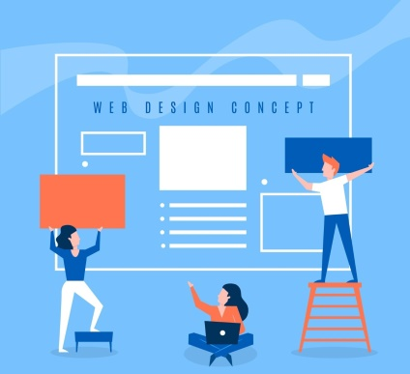

So, Web design is the process of creating websites. It involves planning and building the layout, colours, text styles, images, graphics, and interactive features that appear on a website. Web design makes sure that websites look good, are easy to use, and work well on different devices like computers, tablets, and smartphones. As a web designer, you are the architect crafting a visually appealing and user-friendly webpage.

So, what is a website?
A website is a collection of webpages. More importantly, a web page is a document that contains digital content, and it can be accessed via the World Wide Web through a web browser.

Match the icon in the first column with the correct browser and organisation name in the third column by writing the letter in the second column or drawing a line to connect them in your book.
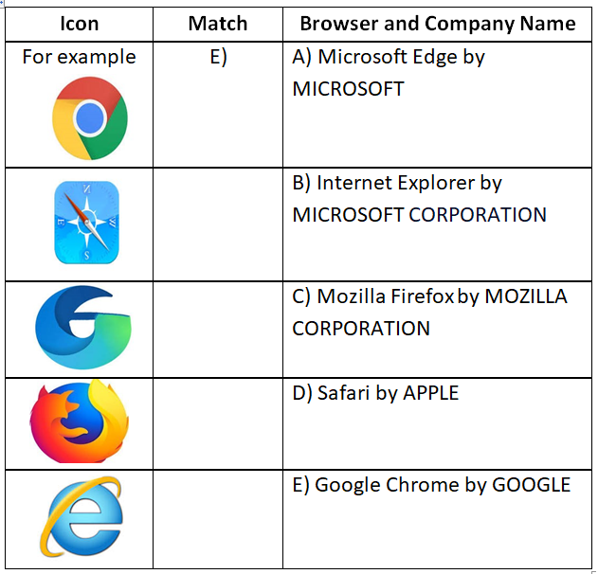
Now that we have explored what a website is, let us understand a webpage and its components.
A web page is a single document containing information on the internet, whereas a website is a collection of related web pages typically under one domain, creating a complete online destination.
To illustrate, think of a website as a book and a web page as one of the pages within that book.

A web page is made up of three main components: HTML for structure, CSS for appearance (style), and JavaScript for behaviour.
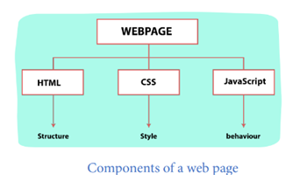
HTML is like the bones of a webpage — it builds the basic structure.
CSS makes the page look nice by adding colors, fonts, and layout.
JavaScript makes the page interactive — like buttons that work or things that move.

Let's inspect a webpage!
As you already know, HTML is the primary language used to build the basic framework of web pages. You can see this in action by visiting a page like Google or other browser and looking at the underlying code.
Here is a guide on how to inspect a webpage
Step 1: Open Your Browser: Start by launching a web browser such as Google Chrome, Mozilla Firefox, or Microsoft Edge.
Step 2: Right-Click to Inspect: Right-click on an empty area of the webpage (avoid images or links).
Step 3: Select 'Inspect': Choose 'Inspect' or 'Inspect Element' from the context menu that appears.
Step 4: Explore the Code: The developer tools panel will open next to the webpage, allowing you to view and interact with the HTML and CSS to understand how the webpage is structured.

